Bài 1:

Bài 2:

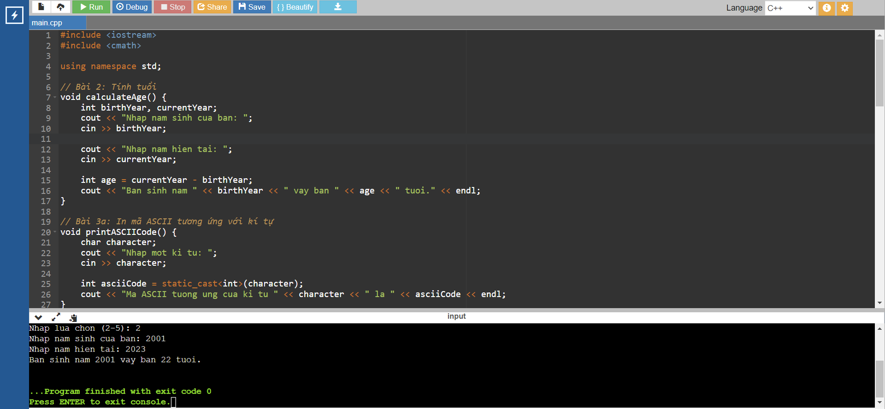

Bài 3:

Bài 4:

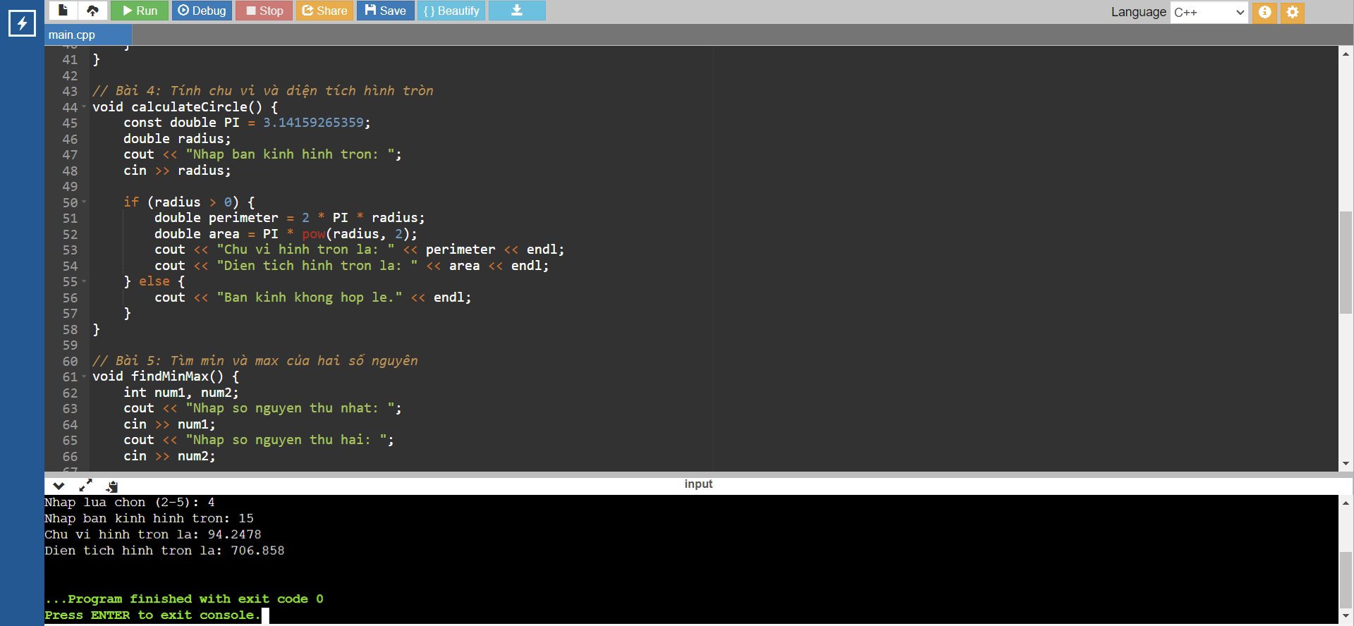

Bài 5:

Ứng Dụng

Bài 1: 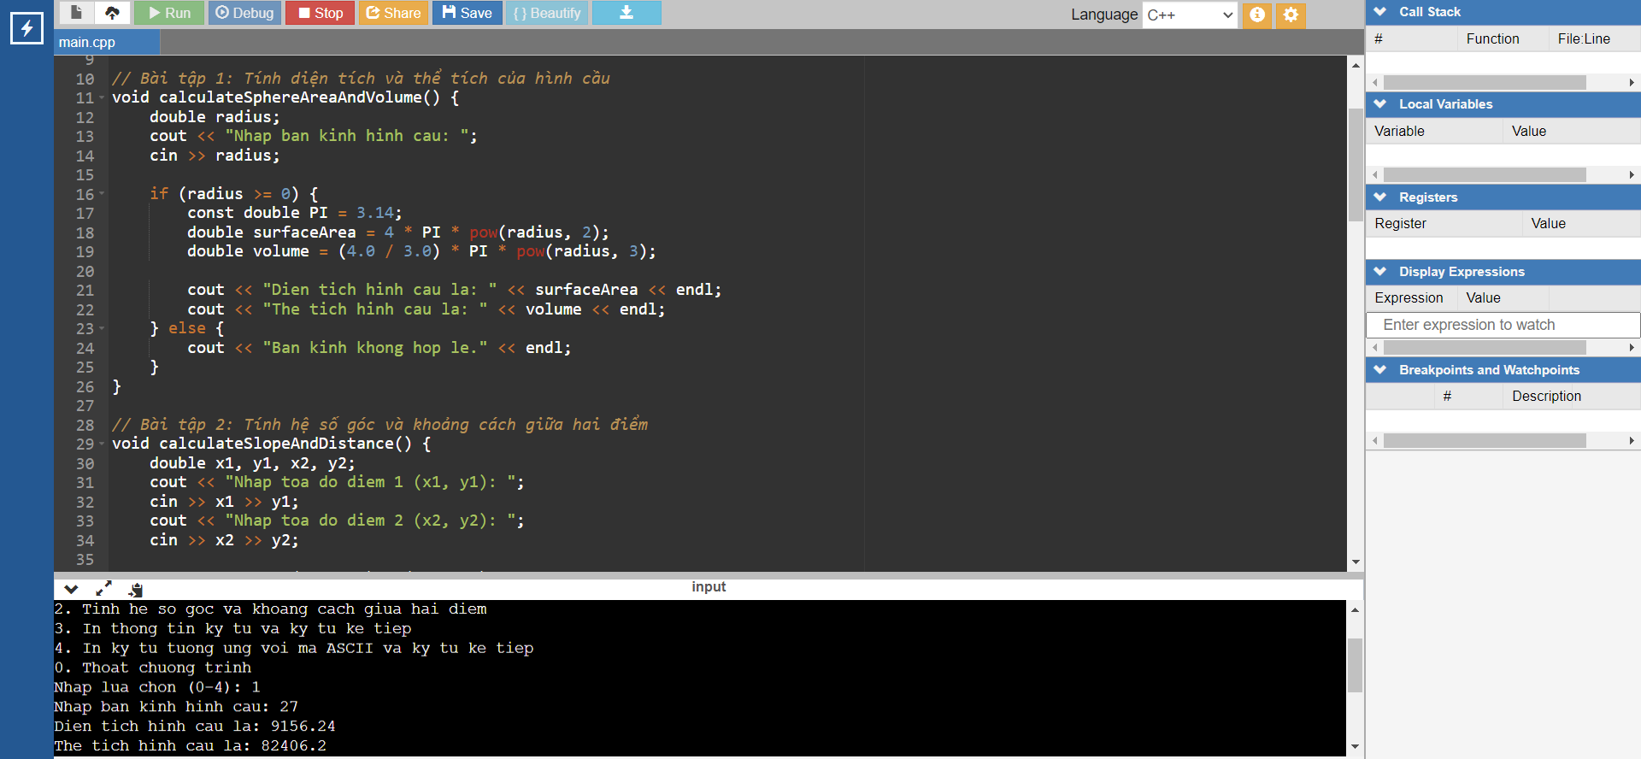

Bài 2: 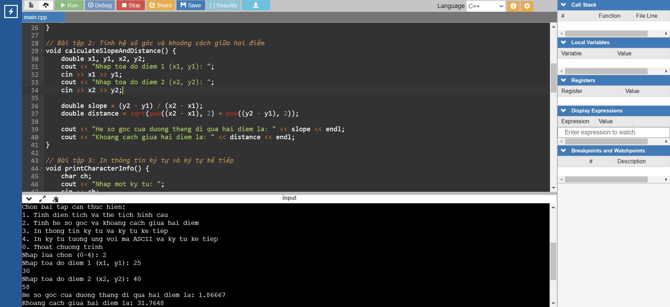

Bài 3: 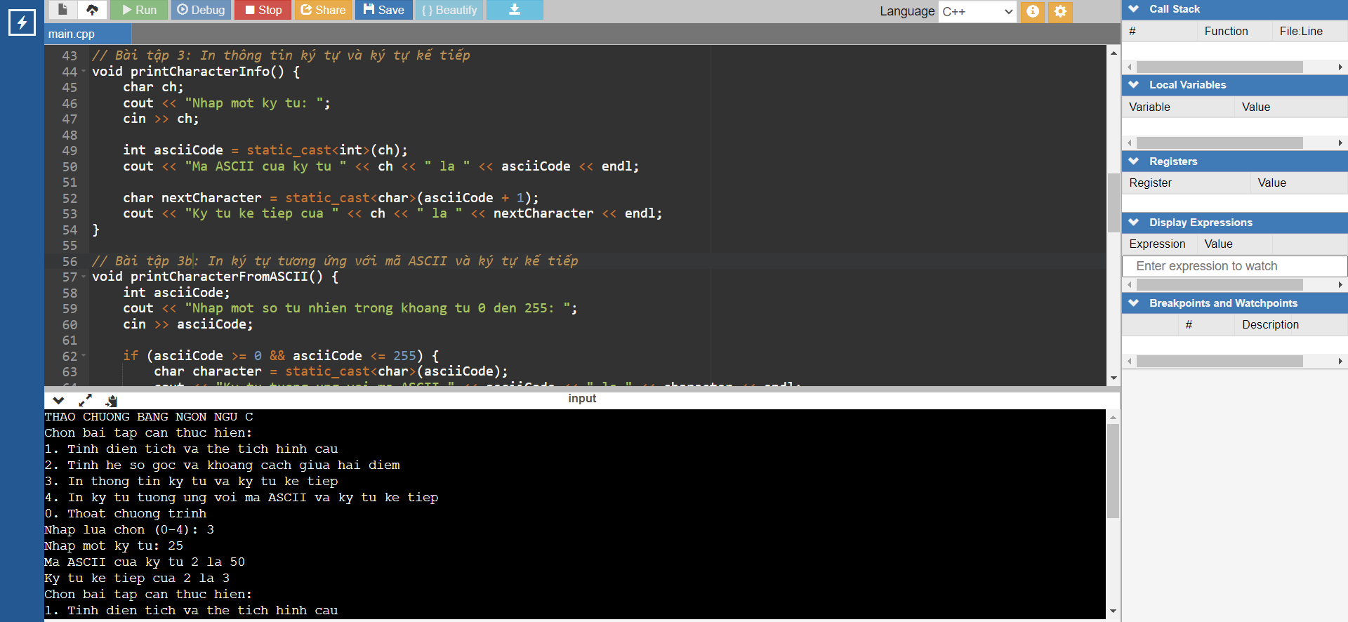

Bài 4:

BONUS  
